Language Access Tools – ***Reverso***

Accurate translations begin with understanding the context in which the language is used. There are many free & paid online tools available to assist with this process. However, it is important to know that not all online translators were created equal.

Reverso is the tool that I would recommend to English-native speakers because it offers the most versatility.

* Reverso is available **online browser** and supports 25 languages <https://context.reverso.net/translation/>
* Downloadable **application for Windows** and supports 16 languages
* **Mobile application** for Android & iOS devices and supports 15 languages

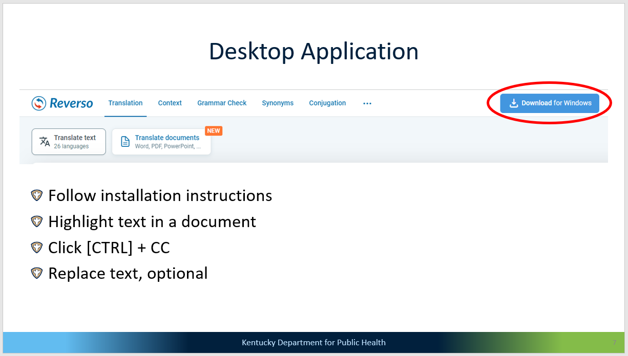

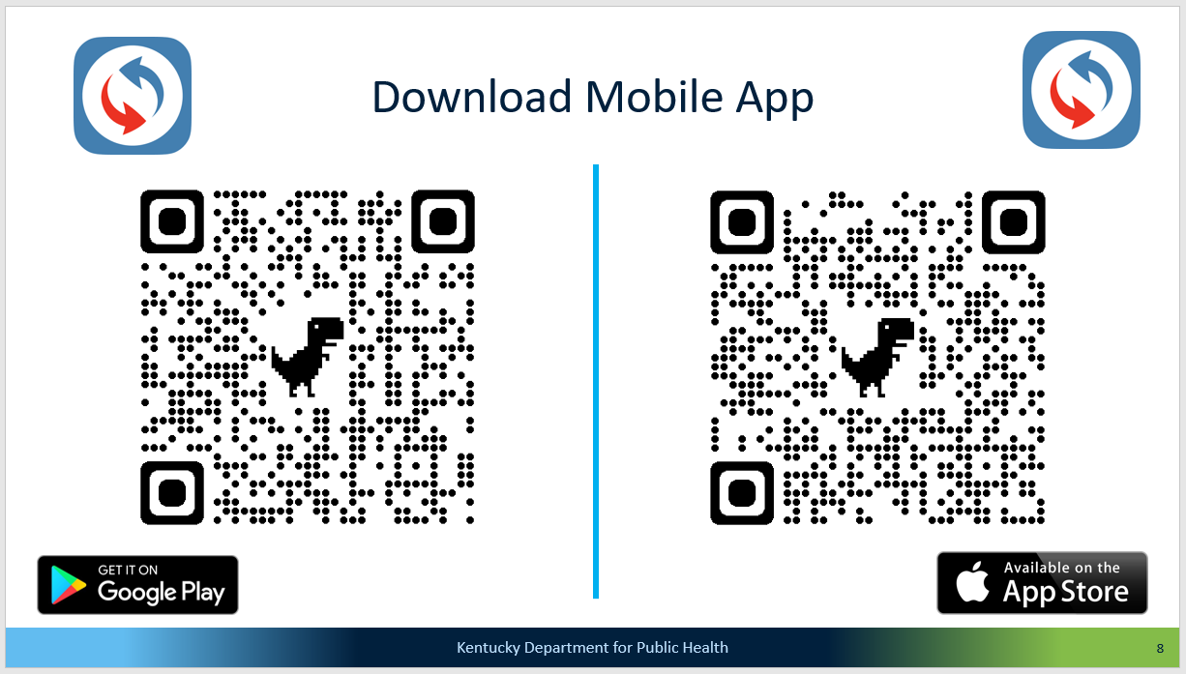

Questions? Contact me at [MariaE.Church@ky.gov](mailto:MariaE.Church@ky.gov)